MEMORIES OF LOVE
Till the End of Time - "Always, Romeo"
Revised Comic / Storyboard Script with Dialogue
Chapter 1: The Hallway

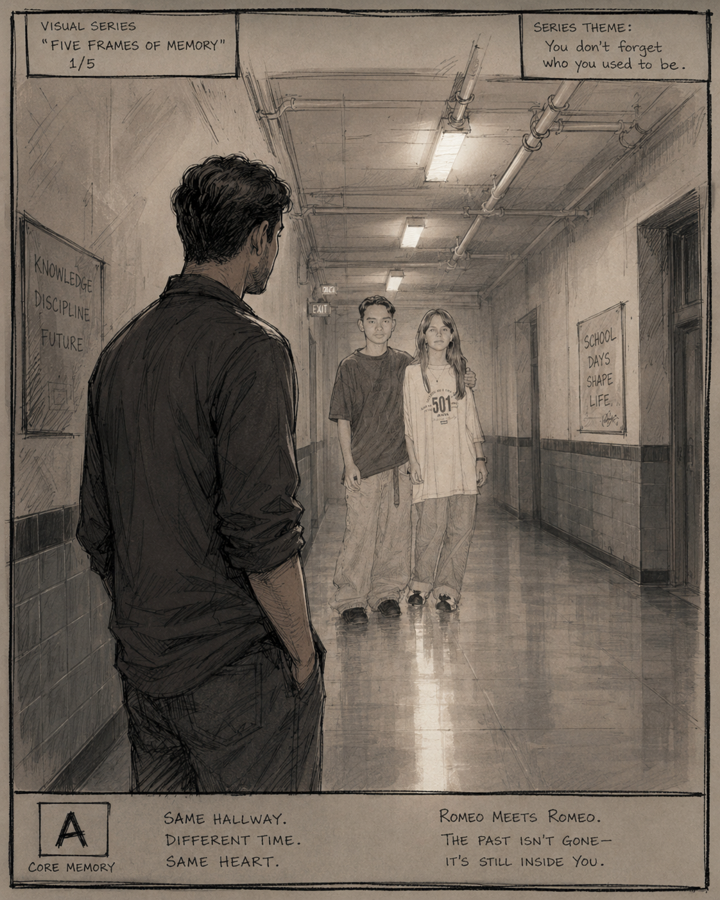
Visual tone reference: Adult Romeo facing the hallway memory.

Private creative draft prepared from Romeo Mesina's memory handoff, Melissa's handwritten letter dated 10-12-95, and the uploaded visual references.

Creative Intent
This revised script treats the memory as a personal comic/storyboard chapter, not simply as a breakup scene. The story is about teenage Romeo encountering first love, heartbreak, betrayal, and the beginning of the protective inner voice later named Leo. The chapter should feel emotional, cinematic, and healing - not violent or revenge-driven.
The central purpose is to bring young Romeo out of the hallway: to witness him, comfort him, and let adult Romeo tell him, "You didn't lose. Your victory is just beginning."

Important Creative Boundary
Leo should be written as a symbolic protector voice or guardian presence born from pain. He is not the main character, not a monster, and not the one who leads the story. Adult Romeo leads. Leo watches the door.
Bon Jovi songs "This Ain't a Love Song" and "Always" may be referenced as emotional soundtrack markers only. Do not reproduce full copyrighted lyrics in the comic/script version unless this remains strictly private and unpublished.

Timeline Reconstruction
Memory Point | Approximate Placement | Script Use
First meeting / school connection | Age about 15, Woodrow Wilson High School | Cafeteria, math class, lunch conversations
Young Romeo asks Melissa out | Before the fight and letter | Direct dialogue: asking if she had a boyfriend and if she wanted to be his girlfriend
Bus-area punch / Romeo holds ground | Shortly before the letter | Romeo chooses not to chase Guillermo because Melissa asks him not to
Letter handoff | On or near October 12, 1995; likely lunch at the football bench | Melissa gives the letter; Romeo tells her his eye does not matter
Letter read at home | Same day after school or that evening, memory unclear | The letter becomes the promise wound
Cafeteria reveal | About a week later in the memory account | Romeo sees Melissa and Guillermo kissing
Third-floor hallway | Immediately after cafeteria reveal | Break point; first protector voice; Leo seed
Adult Romeo returns | Present-day symbolic memory space | Adult Romeo comforts young Romeo and leads him out

Dialogue Authenticity Key
Directly remembered or source-based lines are preserved as closely as possible, including:
- "Do you have a boyfriend?"
- "Would you be interested in becoming my girlfriend?"
- "Stop! Don't do anything, Romeo!"
- "Don't do anything, Romeo."
- "Do you love me?"
- "I'm hurt seeing you this way."
- "I'm okay. I don't care about my eye. All that matters is that I'm with you."
- "I have something to give you. But promise me, no matter what, you won't forget about me, because I'll never forget you."
- "It was them. You saw her face. You saw her lips on his."
- "You did not deserve this. You loved her, and he was your friend."
- "But you are better than this. Someday, you will see."
Adapted dialogue is used only to connect the scene naturally where the memory does not preserve exact wording.

Visual Reference Notes
Adult Romeo should be drawn from the uploaded present-day visual references: short dark hair, blue athletic shirt, muscular build, serious but controlled expression. Young Romeo should be drawn from the high-school hallway photo/reference: teenage, vulnerable, quiet, still trying to be honorable. Melissa should match the memory/photo tone without turning her into a villain. The visual language should show confusion and consequence, not caricature.
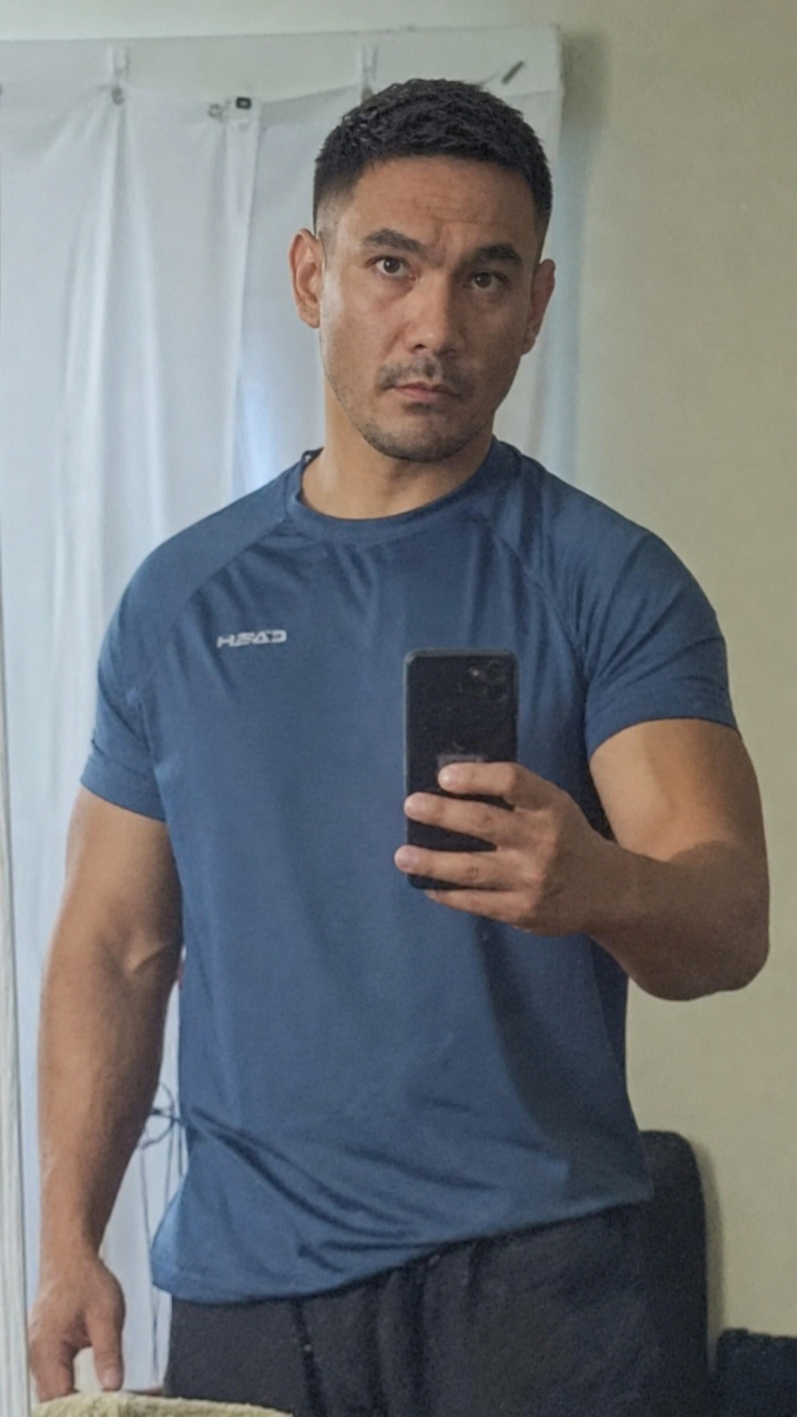  Adult Romeo reference: present-day visual identity. | 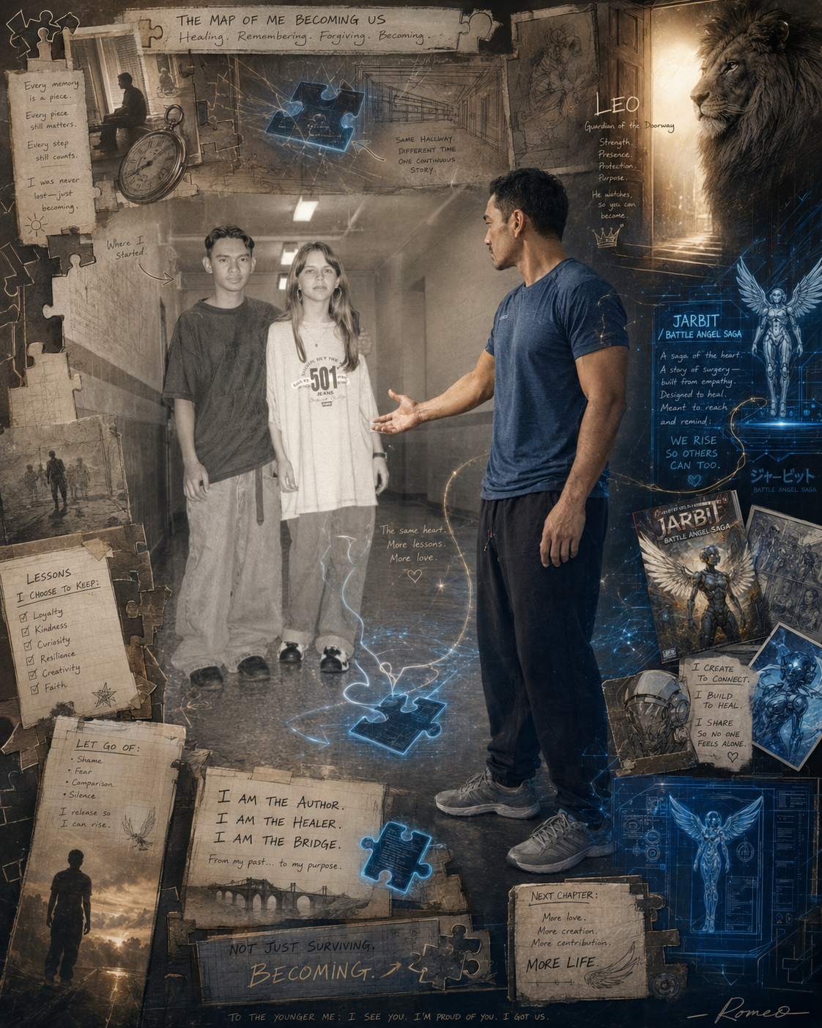  Symbolic map reference: hallway, Leo, JARBIT, and becoming.

Revised Storyboard / Comic Script

PAGE 1 - Present Day: The Letter Opens
Panel 1 - Visual: Adult Romeo sits alone in a quiet room. The old handwritten letter is in front of him. His face is calm, but his hand hesitates before touching the paper.
Caption/Narration: Some memories do not stay buried. They wait until the man is strong enough to look back.
Panel 2 - Visual: Close-up of the letter date: 10-12-95.
Caption/Narration: October 12, 1995. A date written in ink. A wound written somewhere deeper.
Panel 3 - Visual: Adult Romeo reads the opening lines. The room begins to dim as the school hallway fades behind him.
Dialogue: Adult Romeo (thought): I remember this like it happened yesterday.
Caption/Narration: I did not just read a letter. I opened a door.
Panel 4 - Visual: The handwritten paper becomes a hallway light. The sound of old music from 1995 feels distant, like memory echoing through a wall.
Caption/Narration: And on the other side of that door, he was still there.

PAGE 2 - The Hallway Appears
Panel 1 - Visual: Wide shot: Woodrow Wilson High School hallway, memory-toned. Young Romeo and Melissa stand far down the hall. Adult Romeo stands in the foreground, seeing them from behind.
Caption/Narration: Same hallway. Different time. Same heart.
Panel 2 - Visual: Adult Romeo sees young Romeo beside Melissa. For a moment, the adult man cannot move.
Dialogue: Adult Romeo (thought): That is me. That is really me.
Panel 3 - Visual: Young Romeo looks sincere and quiet, still carrying first-love innocence. Melissa stands beside him, not yet understood as pain.
Caption/Narration: Before the hallway became a wound, it was just a school hallway. Before the pain had a name, it was just first love.
Panel 4 - Visual: The hallway lights hum. A faint puzzle-piece shape appears in the shine of the floor.
Caption/Narration: Some pieces only make sense when you return.

PAGE 3 - Cafeteria: First Sight
Panel 1 - Visual: Flashback: cafeteria during lunch. Young Romeo notices Melissa for the first time. The background blurs as if everyone else disappears.
Caption/Narration: I was not looking for love. But when I saw her, something felt different.
Panel 2 - Visual: Young Romeo watches from a distance, nervous and curious.
Dialogue: Young Romeo (thought): Who is she?
Panel 3 - Visual: The cafeteria noise fades into silence around her.
Caption/Narration: It was not dramatic to anyone else. But inside me, something started.
Panel 4 - Visual: Adult Romeo watches the cafeteria memory from outside the scene.
Dialogue: Adult Romeo (thought): This is where the door first opened.

PAGE 4 - Math Class and Courage
Panel 1 - Visual: Math class. Melissa is now in Young Romeo's class. Guillermo is visible elsewhere in the room, normal and friendly at this stage.
Caption/Narration: Then she became my classmate. Math class. Lunch. Little conversations. Enough for hope to grow.
Panel 2 - Visual: Young Romeo gathers courage after class or during a quiet school moment.
Dialogue: Young Romeo: Melissa... can I ask you something?
Panel 3 - Visual: Melissa looks at him. Young Romeo is nervous but honest.
Dialogue: Young Romeo: Do you have a boyfriend?
Panel 4 - Visual: Close-up of Young Romeo, vulnerable but brave.
Dialogue: Young Romeo: Would you be interested in becoming my girlfriend?
Caption/Narration: It was simple. Maybe even innocent. But for me, it was everything.

PAGE 5 - The Bench: The Beginning
Panel 1 - Visual: Outside near the football field stadium bench. Young Romeo waits. Melissa approaches.
Caption/Narration: She asked me to meet her near the football field, by the bench.
Panel 2 - Visual: They sit together. The world around them softens.
Dialogue: Melissa: I wanted to answer you here.
Panel 3 - Visual: Young Romeo listens, frozen in hope.
Dialogue: Melissa: Yes.
Panel 4 - Visual: Young Romeo looks stunned, happy, and quietly overwhelmed.
Caption/Narration: Everyone disappeared. For that moment, there were only the two of us.
Panel 5 - Visual: Adult Romeo observes from the edge of the memory.
Dialogue: Adult Romeo (thought): He believed sincerity would be enough.

PAGE 6 - First Love Grows
Panel 1 - Visual: Montage: Romeo and Melissa at lunch, talking. Hallway glances. Small smiles. Walking together.
Caption/Narration: We started spending lunch together. Talking more. Spending more time with each other.
Panel 2 - Visual: Young Romeo keeps a respectful distance, not rushing her.
Caption/Narration: I respected her. I did not ask for a kiss right away. I thought love meant patience.
Panel 3 - Visual: Melissa laughs at something. Young Romeo smiles shyly.
Dialogue: Young Romeo (thought): Maybe this is what love feels like.
Panel 4 - Visual: Guillermo enters the edge of a panel, still appearing as a friend.
Caption/Narration: Then something changed.

PAGE 7 - Rumors
Panel 1 - Visual: School hallway/cafeteria background. Students whisper. Young Romeo hears fragments.
Dialogue: Student whisper: I heard Melissa and Guillermo...
Caption/Narration: I started hearing things. About him. About her. About them.
Panel 2 - Visual: Young Romeo looks toward Melissa and Guillermo in math class.
Caption/Narration: Guillermo was my friend. That made the wound more confusing before it even became real.
Panel 3 - Visual: Young Romeo tries to speak with Melissa privately.
Dialogue: Young Romeo: Is there something going on with you and Guillermo?
Panel 4 - Visual: Melissa looks away, unable to answer directly.
Dialogue: Melissa: Romeo... I... I don't know what to say.
Note: Adapted bridge dialogue; the memory says she could not talk straight.
Panel 5 - Visual: Young Romeo alone afterward, trying to deny what he feels.
Caption/Narration: I wanted the truth from her. I wanted to believe it was a misunderstanding.

PAGE 8 - After School: The Punch
Panel 1 - Visual: After school near the bus area. Young Romeo walks Melissa toward the bus. The mood feels tense but hopeful.
Caption/Narration: I was finally about to have my first kiss with her when I saw Guillermo walking toward us.
Panel 2 - Visual: Guillermo approaches. Young Romeo does not expect anything.
Dialogue: Young Romeo: Guillermo?
Panel 3 - Visual: Impact panel. Guillermo punches Young Romeo in the right eye.
Note: Keep the violence brief, not glorified. The emotional aftermath matters more than the impact.
Panel 4 - Visual: Young Romeo drops to his knees, vision blurred, hand near his eye.
Caption/Narration: For a moment, I lost my vision.
Panel 5 - Visual: Guillermo runs toward a getaway car in the distance.
Caption/Narration: By the time I could see again, he was running away.

PAGE 9 - Holding Ground
Panel 1 - Visual: Young Romeo begins to move after Guillermo. Melissa grabs him, crying.
Dialogue: Melissa: Stop! Don't do anything, Romeo!
Panel 2 - Visual: Students gather. Some point toward Guillermo's direction.
Dialogue: Crowd voices: Go after him! Get him!
Panel 3 - Visual: Melissa keeps holding Romeo back.
Dialogue: Melissa: Don't do anything, Romeo.
Panel 4 - Visual: Young Romeo looks at Melissa, torn between anger and love.
Dialogue: Young Romeo (thought): I love her. I don't want to hurt her by chasing him.
Panel 5 - Visual: He stands down and walks her to the bus.
Caption/Narration: I held my ground. I thought doing the right thing might still win her heart.
Panel 6 - Visual: A faint shadow, not yet Leo, appears behind Young Romeo like a silent guard.
Caption/Narration: But something inside me took note.

PAGE 10 - The Bench: The Question
Panel 1 - Visual: Next day or near October 12, 1995. Lunch break. Football bench. Young Romeo and Melissa sit together.
Caption/Narration: The next day during lunch, we sat at the football bench where we used to talk.
Panel 2 - Visual: Young Romeo asks the question plainly.
Dialogue: Young Romeo: Do you love me?
Panel 3 - Visual: Melissa looks at his injured eye and starts to break.
Dialogue: Melissa: I'm hurt seeing you this way.
Panel 4 - Visual: Young Romeo leans forward, sincere and wounded.
Dialogue: Young Romeo: I'm okay. I don't care about my eye. All that matters is that I'm with you.
Panel 5 - Visual: Melissa cries. Her hand reaches into her bag for the letter.
Caption/Narration: The words came from the boy who still believed love could survive if he endured enough pain.

PAGE 11 - The Letter
Panel 1 - Visual: Melissa hands Young Romeo the letter.
Dialogue: Melissa: I have something to give you. But promise me, no matter what, you won't forget about me, because I'll never forget you.
Panel 2 - Visual: Close-up of the folded letter in Young Romeo's hand. It carries a faint perfume-memory.
Caption/Narration: It smelled like the perfume she always wore.
Panel 3 - Visual: Young Romeo holds it carefully, choosing not to open it at school.
Dialogue: Young Romeo: I won't forget you.
Note: Adapted response based on the promise moment; exact wording not preserved in memory.
Panel 4 - Visual: Adult Romeo watches the moment from the side of the bench.
Dialogue: Adult Romeo (thought): He did not know he was holding both hope and heartbreak in the same hand.
Panel 5 - Visual: Close-up on date at the top of the letter: 10-12-95.
Caption/Narration: The letter did something dangerous. It gave pain hope.

PAGE 12 - Reading the Letter at Home
Panel 1 - Visual: Young Romeo sits alone at home that evening. The letter is open. Soft 1995 music plays in the background, unnamed or shown as song-title only.
Caption/Narration: A song was playing around that time. I do not remember every detail. But I remember the feeling.
Panel 2 - Visual: Letter overlay: "You are one of the kindest people I have ever met."
Caption/Narration: The words made him feel seen.
Panel 3 - Visual: Letter overlay: "I don't want to be in your past, I want to be in your future."
Caption/Narration: The words gave him a future to hold onto.
Panel 4 - Visual: Letter overlay: "I will always love you..." and the signature "Love Always, Melissa."
Caption/Narration: The word always became a promise. Later, it would become a wound.
Panel 5 - Visual: Young Romeo folds the letter gently and keeps it.
Dialogue: Young Romeo (thought): She still loves me.
Panel 6 - Visual: Adult Romeo stands in the doorway of the room-memory.
Dialogue: Adult Romeo (thought): He believed the letter more than the warning in his chest.

PAGE 13 - The Soundtrack of the Wound
Panel 1 - Visual: A radio/cassette/CD player in the room. The chapter does not show lyrics, only the emotional presence of the songs.
Caption/Narration: Two songs stayed near this memory: Bon Jovi's "This Ain't a Love Song" and "Always."
Panel 2 - Visual: Young Romeo looks at the letter while the room slowly blends with the school hallway.
Caption/Narration: One song felt like the contradiction: this was supposed to be love, but it felt like grief.
Panel 3 - Visual: Close-up of the word "Always" on the letter. Young Romeo traces it with his eyes, not his finger.
Caption/Narration: The other song felt like the attachment: even after pain, part of him still loved.
Panel 4 - Visual: Adult Romeo appears behind him, compassionate but sad.
Dialogue: Adult Romeo: You were not stupid for believing her. You were young. You loved with your whole heart.
Panel 5 - Visual: The shadows of the room stretch into hallway tiles.
Caption/Narration: Sometimes a song becomes a memory because your heart was breaking quietly when you heard it.

PAGE 14 - One Week Later: The Cafeteria Door
Panel 1 - Visual: Young Romeo approaches the cafeteria door during lunch. He is nervous but hopeful.
Caption/Narration: A week later, I kept hearing rumors. But I doubted them. I told myself she would not leave me for him.
Panel 2 - Visual: Close-up: his hand pushes the cafeteria door open.
Caption/Narration: Then I opened the door.
Panel 3 - Visual: Reveal: Melissa and Guillermo kissing. Keep the panel distant and stark, not sensationalized.
Caption/Narration: That was the moment the letter and reality collided.
Panel 4 - Visual: Young Romeo steps backward out of the cafeteria.
Caption/Narration: I stepped back and left the area.
Panel 5 - Visual: The hallway outside looks impossibly long.
Caption/Narration: I found myself on the third-floor hallway, walking mindlessly.

PAGE 15 - Third-Floor Hallway: The Break Point
Panel 1 - Visual: Young Romeo alone in the hallway. His face is blank at first, like he cannot process what he saw.
Caption/Narration: It hurt like someone punched me in the stomach and ran away.
Panel 2 - Visual: He walks, disoriented. The fluorescent lights repeat above him.
Dialogue: Young Romeo (thought): Maybe it was not really them. Maybe I saw wrong.
Panel 3 - Visual: A voice box appears without a speaker. No body yet. Just truth.
Dialogue: Voice: It was them. You saw her face. You saw her lips on his.
Panel 4 - Visual: Tears start falling from Young Romeo's eyes.
Dialogue: Voice: You did not deserve this. You loved her, and he was your friend.
Panel 5 - Visual: Young Romeo grips the letter in his memory, even if not physically holding it in the hallway.
Caption/Narration: The letter said always. The hallway said gone.

PAGE 16 - The First Leo Seed
Panel 1 - Visual: The hallway darkens slightly behind Young Romeo. A distant lion-shadow or guardian outline appears near a doorway, subtle and protective.
Dialogue: Voice: But you are better than this. Someday, you will see.
Panel 2 - Visual: Young Romeo leans against the wall, crying.
Caption/Narration: He did not know it yet, but something inside him refused to let him disappear.
Panel 3 - Visual: Adult Romeo stands at the far end of the hallway, now fully visible in memory-space.
Dialogue: Adult Romeo: I see you.
Panel 4 - Visual: The guardian presence remains behind Young Romeo, not attacking, only watching.
Caption/Narration: Years later, I would give that protecting fire a name: Leo.
Panel 5 - Visual: Adult Romeo walks toward the boy.
Caption/Narration: Not to erase the past. To retrieve what was left there.

PAGE 17 - Adult Romeo Reaches Him
Panel 1 - Visual: Adult Romeo kneels beside Young Romeo in the hallway.
Dialogue: Adult Romeo: Hey. I found you.
Panel 2 - Visual: Young Romeo looks up, confused and crying.
Dialogue: Young Romeo: Who are you?
Panel 3 - Visual: Adult Romeo puts a hand gently on his shoulder.
Dialogue: Adult Romeo: I'm you. I came back because you should not have been left here alone.
Panel 4 - Visual: Young Romeo looks toward the cafeteria door in the distance.
Dialogue: Young Romeo: I believed her.
Panel 5 - Visual: Adult Romeo answers without judgment.
Dialogue: Adult Romeo: I know. You were not foolish. You were sincere.
Panel 6 - Visual: Adult Romeo looks him straight in the eyes.
Dialogue: Adult Romeo: You did not lose. Your victory is just beginning.

PAGE 18 - The Guard at the Door
Panel 1 - Visual: Adult Romeo helps Young Romeo stand. Leo remains as a lion-like shadow/guardian at the doorway, not threatening.
Dialogue: Adult Romeo: Leo, guard the door. Do not lead. Do not destroy. Just watch.
Panel 2 - Visual: The guardian presence lowers its head slightly. It is not defeated; it is contained.
Caption/Narration: Standing down does not mean kneeling. It means the boy is no longer alone.
Panel 3 - Visual: Young Romeo wipes his face.
Dialogue: Young Romeo: What happens now?
Panel 4 - Visual: Adult Romeo begins walking him down the hallway toward light.
Dialogue: Adult Romeo: We leave the hallway.
Panel 5 - Visual: The hallway behind them becomes less sharp, more like a memory than a prison.
Caption/Narration: The past did not change. But the boy no longer had to live there.

PAGE 19 - JARBIT / Battle Angel Foreshadow
Panel 1 - Visual: As they exit, small puzzle pieces glow on the floor. One piece shows a faint JARBIT blueprint. Another shows wings, a core, and a shield-like symbol.
Caption/Narration: Far ahead, pain would become story.
Panel 2 - Visual: Adult Romeo sees flashes: JARBIT, Battle Angel Saga, Rebuilt, Rebirth, guardian imagery.
Caption/Narration: Not because the wound was beautiful. Because survival needed a language.
Panel 3 - Visual: Young Romeo watches the images, not understanding yet.
Dialogue: Young Romeo: What is that?
Panel 4 - Visual: Adult Romeo gives a small, sad smile.
Dialogue: Adult Romeo: Something we build later. Something that helps us explain what words could not.
Panel 5 - Visual: The Leo guardian watches from the door, now behind them.
Caption/Narration: The guard stayed. But the author returned.

PAGE 20 - Closing Letter: Always, Romeo
Panel 1 - Visual: Present day. Adult Romeo closes Melissa's letter and places it gently on the table, no longer clenched.
Caption/Narration: The letter was real. The pain was real. But the hallway was not the whole story.
Panel 2 - Visual: Adult Romeo writes a new line on a blank page - not to Melissa, but to young Romeo.
Dialogue: Adult Romeo (writing): You did not lose. Your victory is just beginning.
Panel 3 - Visual: The blank page now bears the chapter title.
Caption/Narration: Memories of Love: Till the End of Time - "Always, Romeo"
Panel 4 - Visual: Final image: Young Romeo and Adult Romeo walking out of the hallway together.
Dialogue: Adult Romeo: I came back for you.
Panel 5 - Visual: The last panel shows the hallway empty but peaceful. The light remains on.
Caption/Narration: End of Chapter 1: The Hallway. To be continued: The Guard at the Door.

Dialogue Bank for Future Revision
Use this section to keep the emotionally important lines consistent across future drafts.

Young Romeo to Melissa
- "Do you have a boyfriend?"
- "Would you be interested in becoming my girlfriend?"
- "Are you and Guillermo together?"
- "Do you love me?"
- "I'm okay. I don't care about my eye. All that matters is that I'm with you."

Melissa to Young Romeo
- "Stop! Don't do anything, Romeo!"
- "I'm hurt seeing you this way."
- "I have something to give you. But promise me, no matter what, you won't forget about me, because I'll never forget you."
- Letter feeling: She sees him as kind and special, says she is confused, says she thinks about him constantly, says she does not want to be in his past, wants to be in his future, and signs with "Love Always."

First Protector Voice / Leo Seed
- "It was them. You saw her face. You saw her lips on his."
- "You did not deserve this. You loved her, and he was your friend."
- "But you are better than this. Someday, you will see."

Adult Romeo to Young Romeo
- "Hey. I found you."
- "I'm you. I came back because you should not have been left here alone."
- "You were not foolish. You were sincere."
- "You did not lose. Your victory is just beginning."
- "We leave the hallway."
- "I came back for you."

Adult Romeo to Leo
- "Leo, guard the door. Do not lead. Do not destroy. Just watch."
- "Standing down does not mean kneeling. It means the boy is no longer alone."

Source Notes
Primary memory source: High School First Love Memory & Reflection Handoff document, including Romeo's polished memory entry and reflection conversation.
Primary letter source: Melissa's handwritten letter dated 10-12-95. Letter excerpts are used as private story reference material.
Visual source: uploaded reference images of present-day Romeo, hallway/storyboard concepts, puzzle-map imagery, and graveyard/memory symbolism.
Timeline note: exact timing is uncertain. The letter date anchors the letter scene to October 12, 1995, but the script preserves uncertainty by saying "on or near" that date where appropriate.
Song note: Bon Jovi song titles may be referenced as soundtrack memory markers, but lyrics are not reproduced in this draft.

